**Advance Excel Assignment - 6**

1. **What are the various elements of the Excel interface? Describe how they're used.**

1. Ribbon: the ribbon has various tabs, each tab has different set of commands. The button and icons of the excel ribbon are organized into separate tabs based on their functionalities. Home, Insert, Page Layout, Formulas, Data, Review, and view are the seven tab. Each tab has its own set of related commands.
2. Title bar: it is next to quick access toolbar. It shows the name of the currently open documents.
3. Quick access tool bar : it is next to title bar. It provides most commonly used command. This toolbar can be customized to suit your needs.
4. Formula bar: we can enter formula for any cell. A user can select any cell and can write formula which is needed.
5. Name box: it shows the name or location of the selected cell.
6. Zoom slider: is used to zoom in or zoom out the sheet.

**2. Write down the various applications of Excel in the industry.**

1. Data entry and storage : excel is best tool to organize and store the data in tabular format. But the size of the data stored in excel is limited. We can use this file for various purpose, if stored in excel.
2. Performing calculations: we can perform various mathematical operations on the excel sheet by using various built-in functions and formulas. Mathematical, statistical, logical, string, and data time functions which are most commonly used in excel.
3. Data Analysis and Interpretation: excel has many features for data analysis that can directly assist any organization in making decisions and gaining meaningful insights from data. There are many features such as pivot table, sorting, filtering, and conditional formatting.
4. Reporting and Visualization: excel has built in charts that can be used for visualization. Excel has line chart, bar chart, pie chart and many more. Excel is used to create dashboards with all charts.
5. Accounting and Budgeting: excel has many accounting and budgeting templates that helps to keep record easier. Make computations, some of them include basic to advanced formulas. This allows managers to use the information from Excel and share it with others when necessary for the organization.

**3. On the ribbon, make a new tab. Add some different groups, insert commands in the groups and name them according to their commands added. Copy and paste the screenshot of the steps you followed.**

* Right click on the ribbon and select customize the ribbon

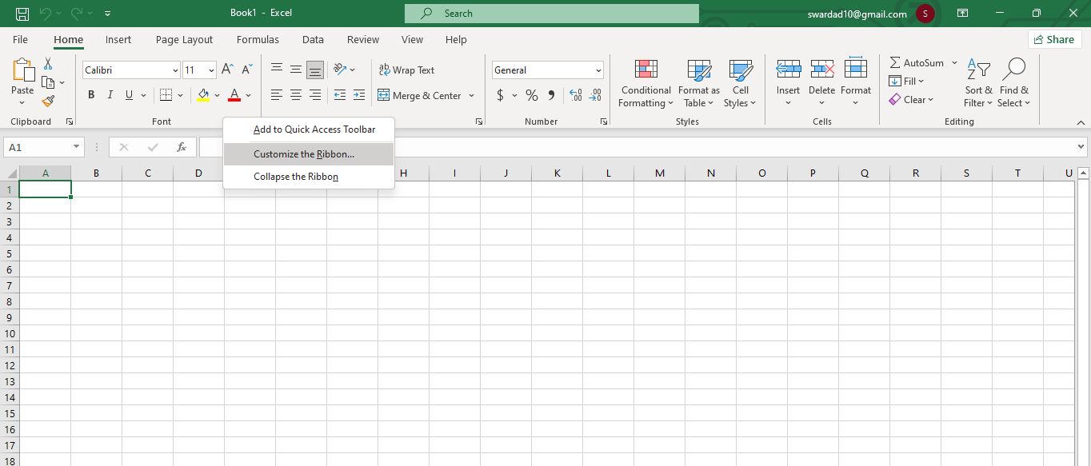

* Excel options will open up, click on new table rename the tab, then click ok.

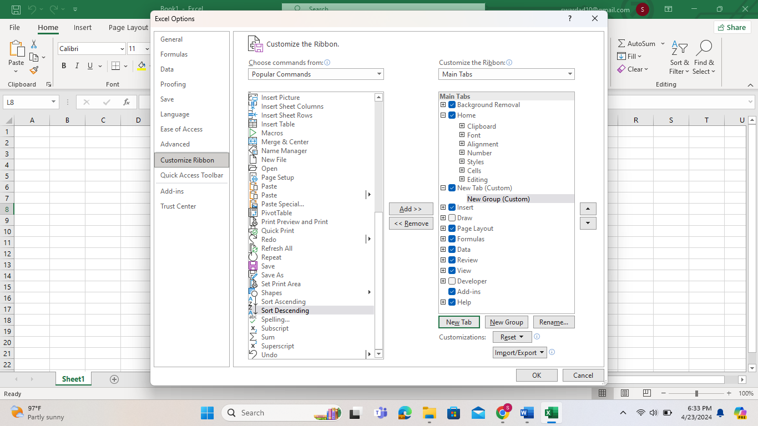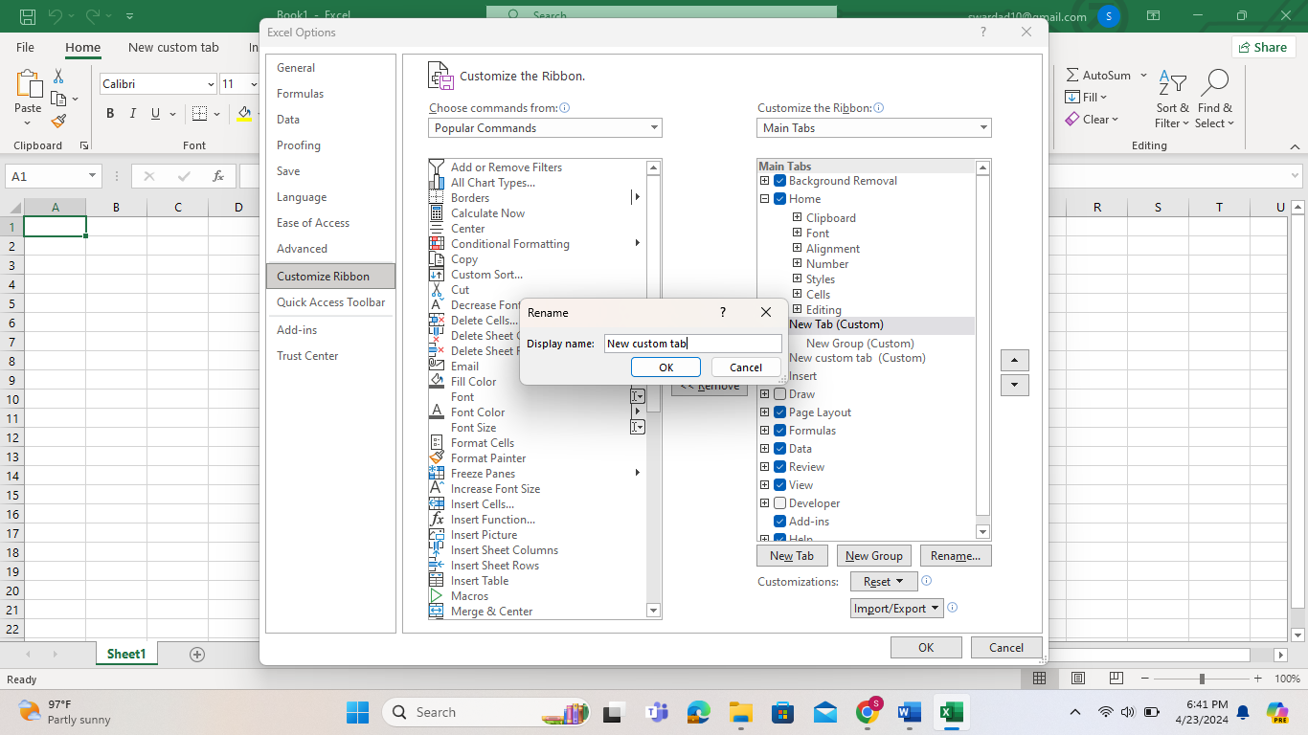

* Also rename the new group by clicking on rename, give the name and click ok.

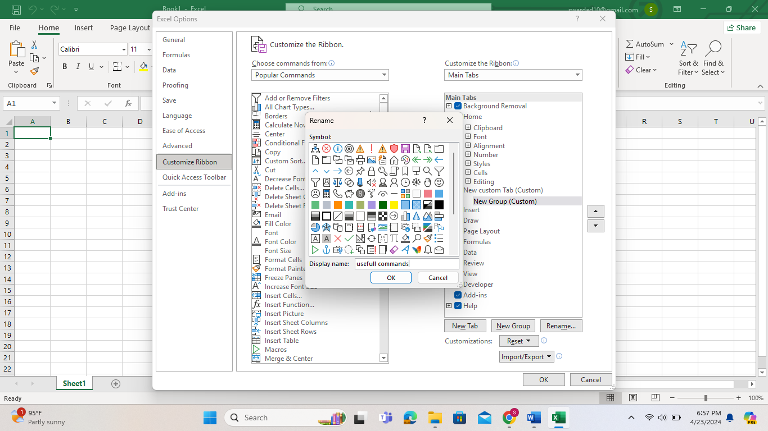

* Select the commands that you want to add in the new custom tab and click add, the command will get added in the custom tab. After selecting the commands click ok, you can see the tab on ribbon.

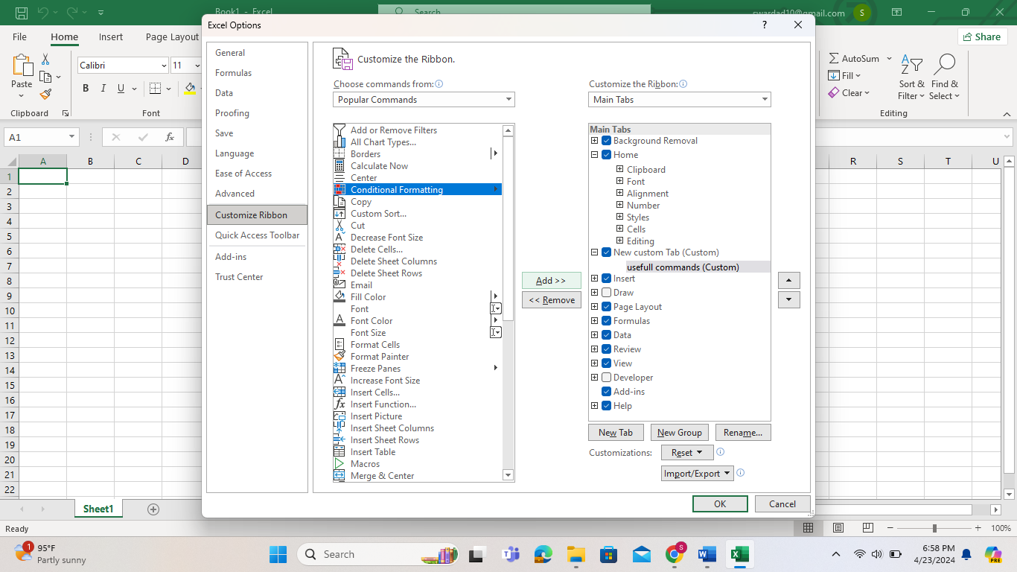

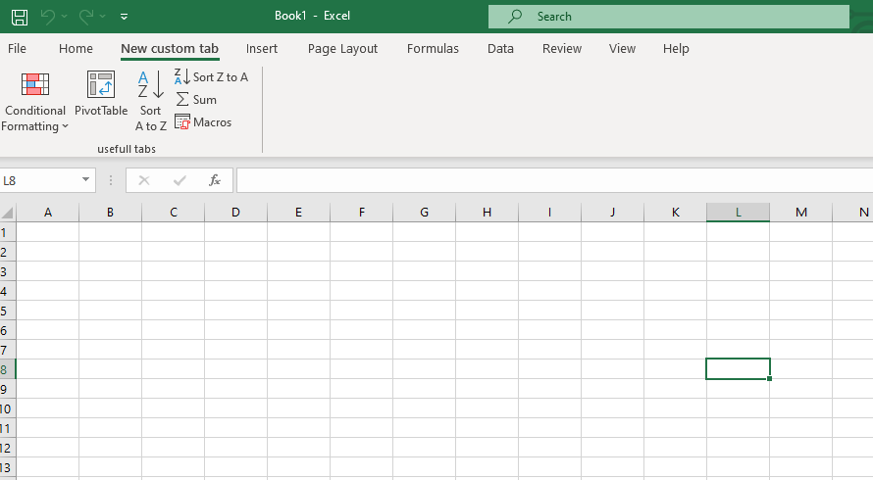

**4. Make a list of different shortcut keys that are only connected to formatting with their functions.**

|  |  |
| --- | --- |
| **Keys** | **Functions** |
| Ctrl + B | To make the font bold |
| Ctrl + L | To make the format in italic text |
| Ctrl + U | It is used to underline the text |
| Ctrl + Shift + > | Increase the font size |
| Ctrl + Shift + < | Decrease the font size |
| Shift + F3 | To change to font between upper, lower and title |
| Ctrl + Shift + D | Double underline format |

**5. What distinguishes Excel from other analytical tools?**

|  |  |
| --- | --- |
| **EXCEL** | **POWER** **BI** |
| Excel can handle limited amount of data | Power bi can handle large amount of data |
| Excel is more focused on creating static charts and graph | Power bi is designed to create dynamic and interactive visualizations |
| Excel doesn’t offer collaboration features | Power bi offer several collaboration features |
| Excel can not connect to live data sources | Power bi connects to live data sources, allowing for up to minute analysis and dashboard. |

**6. Create a table and add a custom header and footer to your table.**

* Create a table, go to page layout click on down arrow next to sheet option dialog box will appear on page.

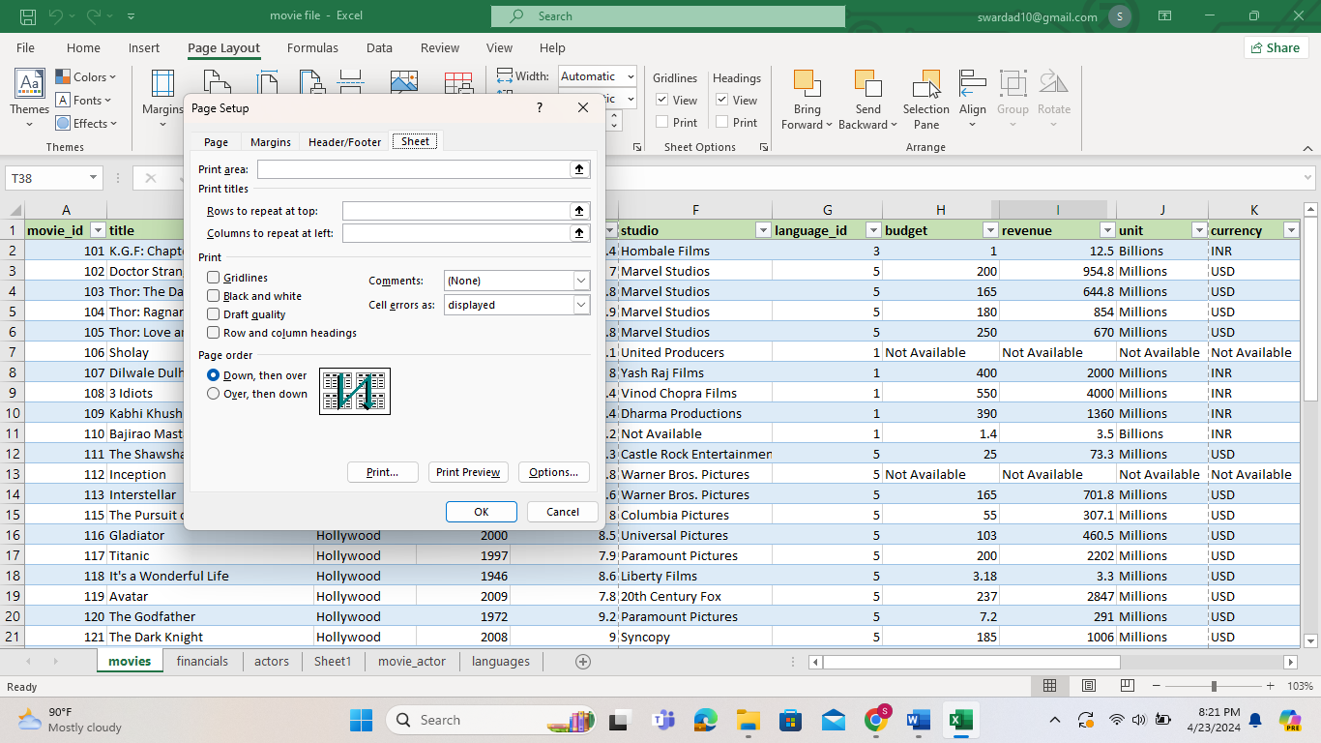

* Click on header and footer, click on custom header and add the according to your choice. Click ok
* Click on custom footer add the feature that you want. Click ok when you click on print preview you can see the changes have add in it.

